Section 2

User Interface

for

Bug Tracker Application

Version 1.0 approved

Prepared by Group 12

CSCI222, University of Wollongong

27 October 2016

Contents

1. Login 3

2. Guest Register 4

3. Main Screen / Search Bug Screen 5

4. Add Bug 6

5. View Bug 7

6. Edit Bug 8

7. Search User 9

8. View Profile 10

9. Edit Profile 11

10. Add User 12

11. Generate Report 13

Figure 1 Login Screen 3

Figure 2 Register Screen 4

Figure 3 Main Scree 5

Figure 4 Add Bug Screen 6

Figure 5 View Bug 7

Figure 6 Edit Bug 8

Figure 7 Search User 9

Figure 8 View Profile 10

Figure 9 Edit Profile 11

Figure 10 Add User 12

Figure 11 Generate Report 13

# Login

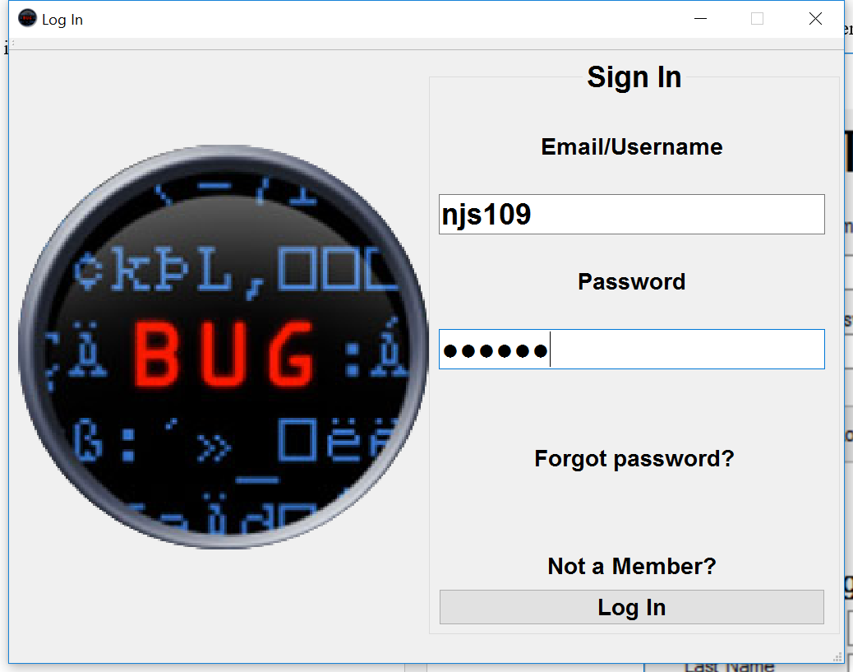Each user is presented with this screen when the program is first executed. They must log in to continue and access the BugTracker system.

Figure 1 Login Screen

The user has 3 options from this point, they can either:

* Log in using their email and password
* Select the Forgot Password link, which presents them with a GUI to send a request to the System Administrator to reset their password
* Select the Not a Member link, which will present them with additional information to either continue as a guest with limited access, or to register as a Reporter.

# Guest Register

This screen is shown when a guest user wants to use the BugTracker System.

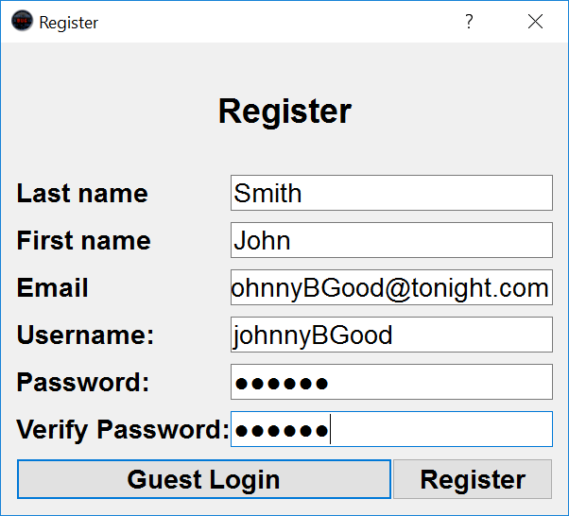

Figure 2 Register Screen

The guest can then choose to either:

* Register their email into the system to become a Reporter
* Continue as a guest user with limited access

# Main Screen / Search Bug Screen

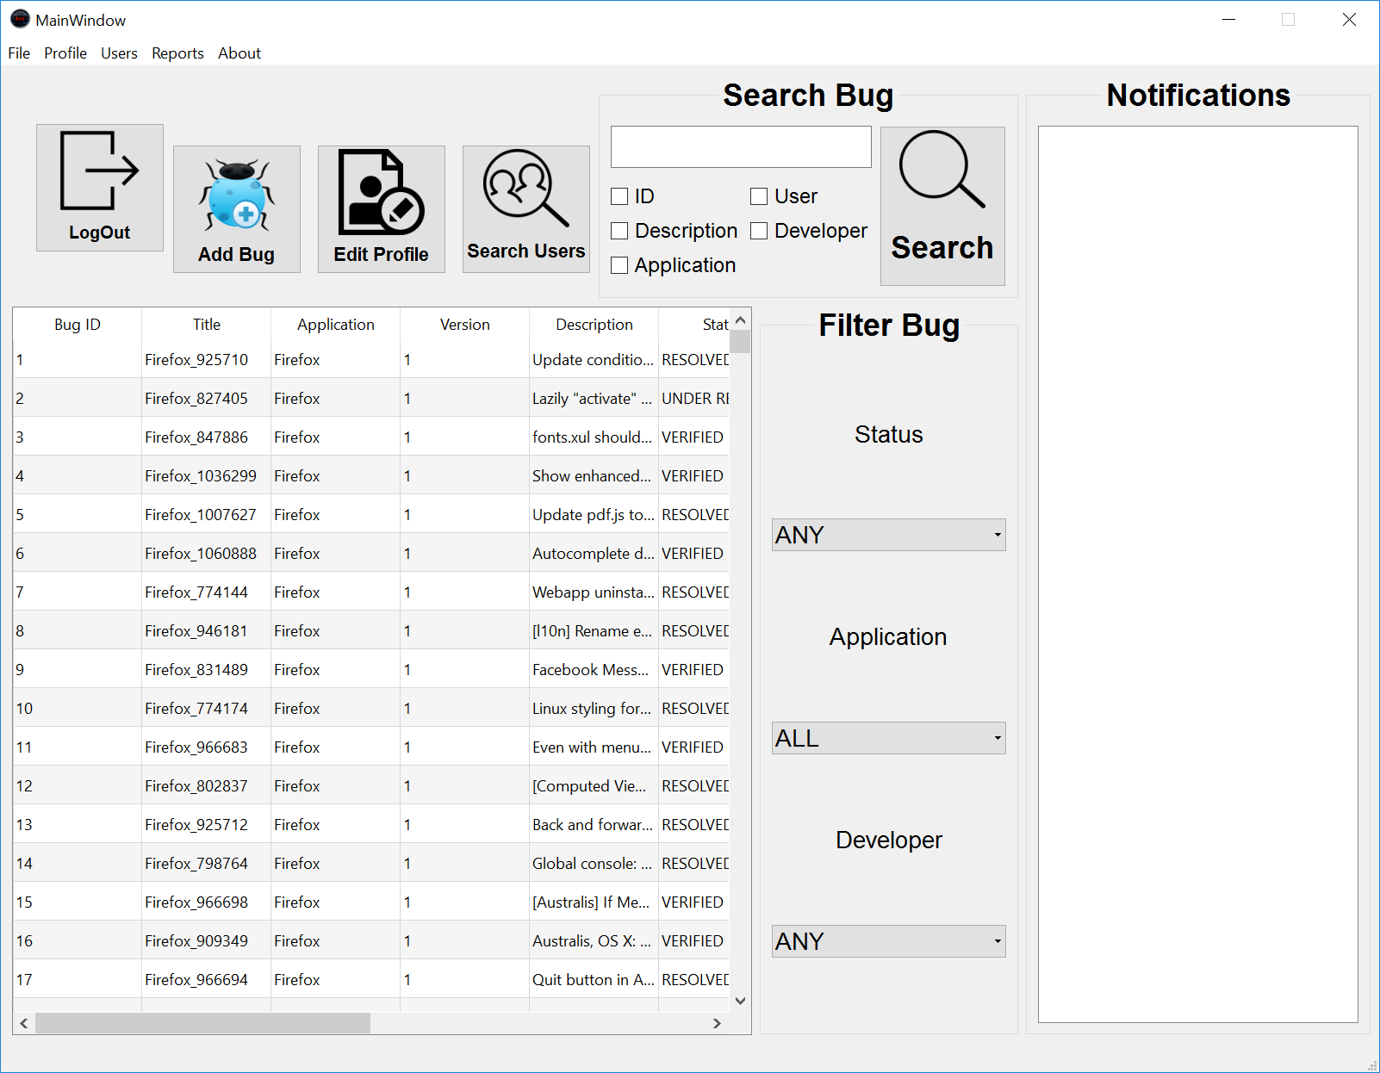This is the main GUI that every user sees after they have logged into the BugTracker System.

Figure 3 Main Scree

This GUI is where most of the functions can be accessed. This screen has the following features:

* Bug List – this is a table format showing the results of the bug search function and filter functions. Default shows the latest 30 bugs in the database.
* Search Box – this is where a user can use keywords to search the database for any bugs related to their search criteria. The user can search by Bug ID, Bug Description, Product, User and Developer, or any combination of the above.
* Filter Bugs – this function allows the user to filter the search results. The user can filter the bugs by; Status, Application, Developer.
* Menu Strip – the menu items within this strip are subject to change depending on the user who logged in,
* Notification Box – this is where the user receives their notifications from their subscribed bugs and any System related messages.

# Add Bug

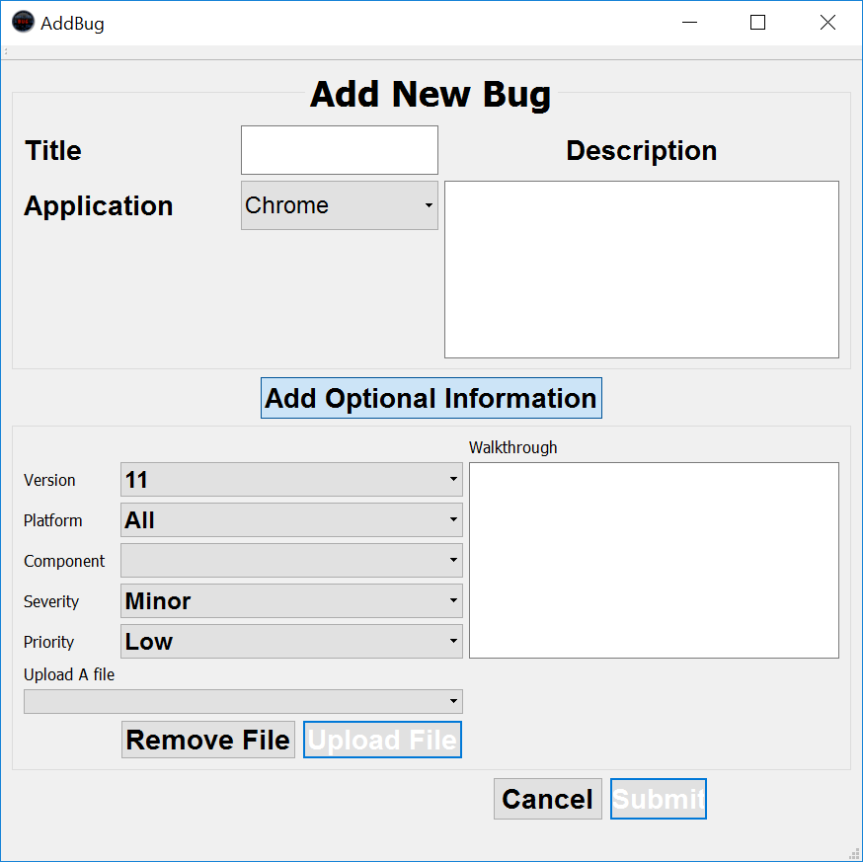This GUI is where any user (excluding guest) can Report a bug into the BugTracker System.

Figure 4 Add Bug Screen

This GUI allows a user to Report a bug into the system.

It is divided into 3 sections:

* Top – this sections holds the mandatory fields required to submit a bug, the Title, Application and a short Description of the bug.
* Middle – this section can be hidden/unhidden by the user and holds the input fields for the optional information such as version, priority and Walkthrough.
* Bottom – this section is used to upload any files the user wished to add to the bug, such as screenshots, log files. Also contains buttons for submitting and cancelling.

# View Bug

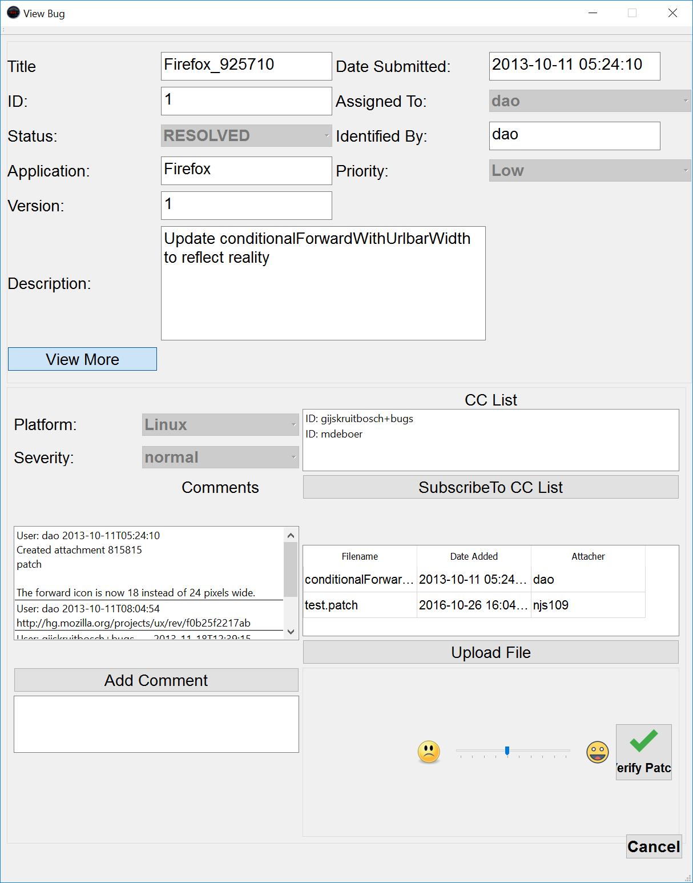This GUI shows users information about a Bug already in the BugTracker System

Figure 5 View Bug

This GUI shows all the information on the currently selected bug.

This view is divided into 4 sections:

* Top Section – shows the basic information about the bug, such as ID, Title, version, Application, date submitted and developer assigned to it.
* First Middle – contains further information including the platform severity and the CC list of all users who are currently subscribed to receive updates.
* Second Middle – shows a list of all the attachments associated with the bug.
* Bottom Section – this section shows the comments.

# Edit Bug

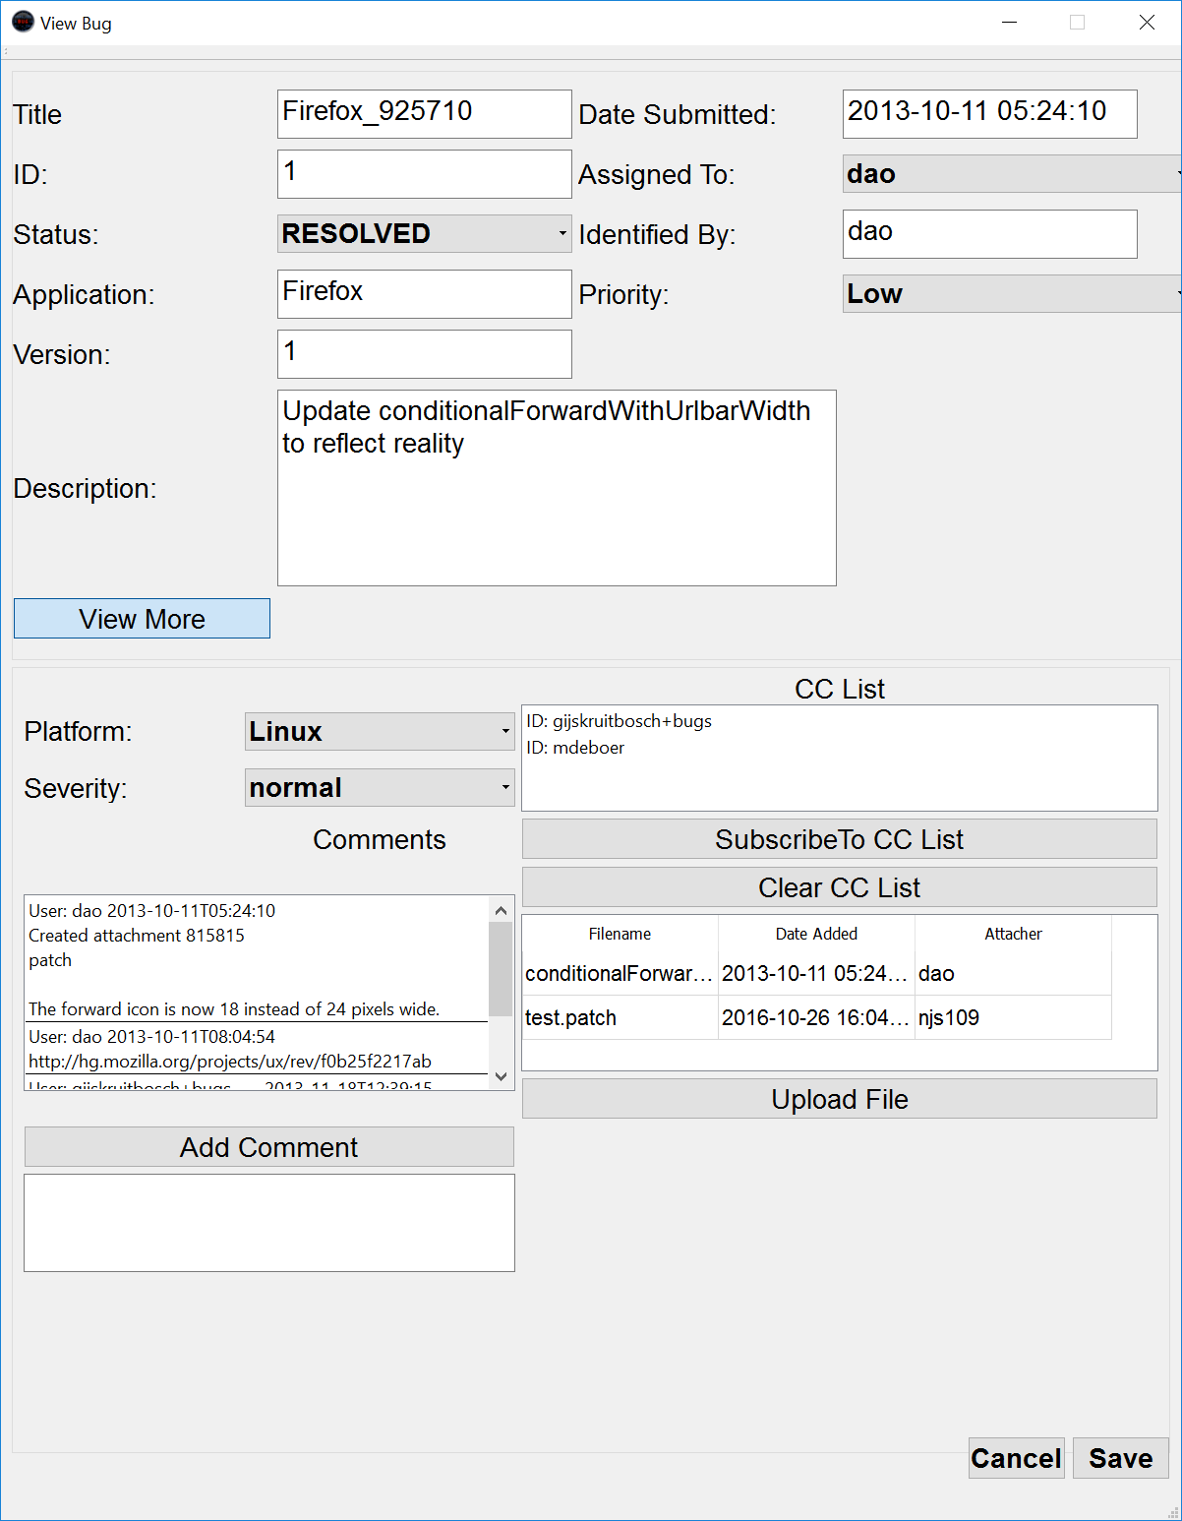This GUI is for Triagers to manage an existing bug in the BugTracker System.

Figure 6 Edit Bug

This GUI is similar to the above ViewBug GUI but contains editable text areas to allow a Triager to update and modify details about the bug, including its lifecycle. This screen also allows the Triager to assign the bug to a particular developer. Other functions include:

* Remove users from CC list
* Remove attached Files
* Clear comments

# Search User

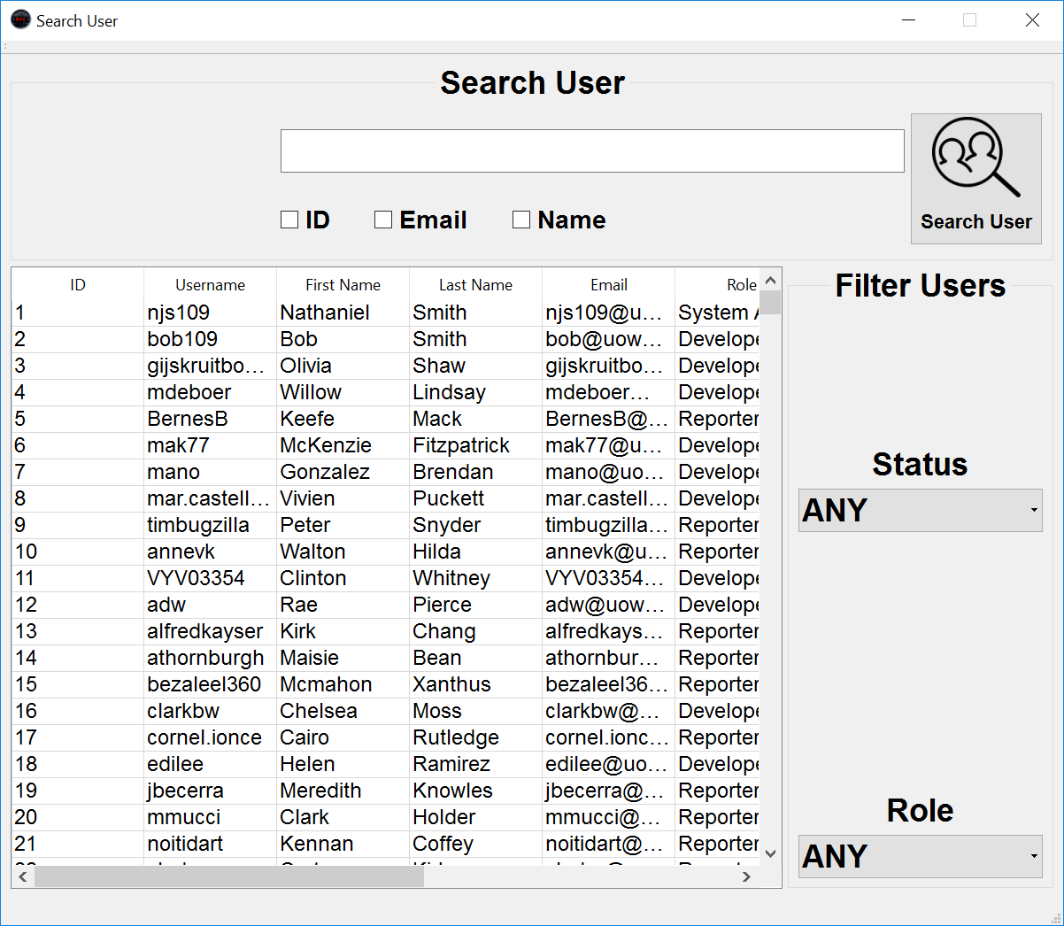This GUI is available to all registered users and allows users to search for other users within the BugTracker system and view their profile.

Figure 7 Search User

This GUI allows users to search for existing users within the BugTracker System

Features such as:

* User List – this is a table format showing the results of the user search function and filter functions. Default shows all users in the database.
* Search Box – this is where a user can use keywords to search the database for any users related to their search criteria. The user can search by username, name, email, country, role, or any combination of the above.
* Filter User – this function allows the user to filter the search results. The user can filter the users by; Status, Role.

# View Profile

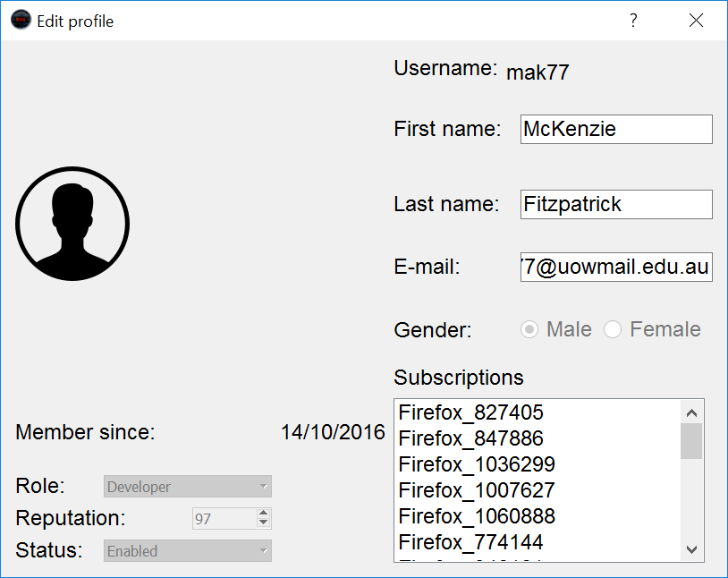This GUI shows a user’s profile information. This is accessed by searching the system for users.

Figure 8 View Profile

This GUI is a read-only hat shows details of the user. This is a public profile and all information is available for viewing by all users of the system. Information shown includes:

* Username
* First Name
* Last Name
* Email
* Profile Picture
* Role
* Reputation
* Status
* Date Added to system
* Current subscriptions

# Edit Profile

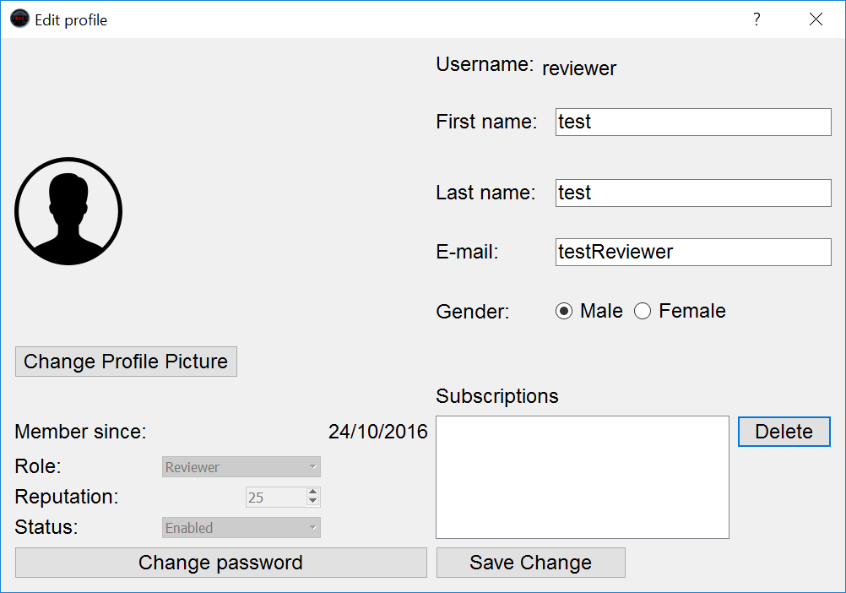This GUI allows a user to edit their own profile, and a System Administrator to edit all profiles

Figure 9 Edit Profile

This GUI is one that differs depending on the user logged in. Each user can edit their own profile, and System Administrator can edit any user’s profile.

Each user can change the following information on their own profile:

* First Name
* Last Name
* Email
* Subscriptions
* Password
* Profile Picture

They can not change their reputation, role or status.

System Administrators have access to change the following information on any profile:

* First Name
* Last Name
* Email
* Profile Picture
* Password(reset not view)
* Reputation
* Role
* Status (Ban the user)

# Add User

This GUI is for System Administrators and is used to Add a New User to the BugTracker System.

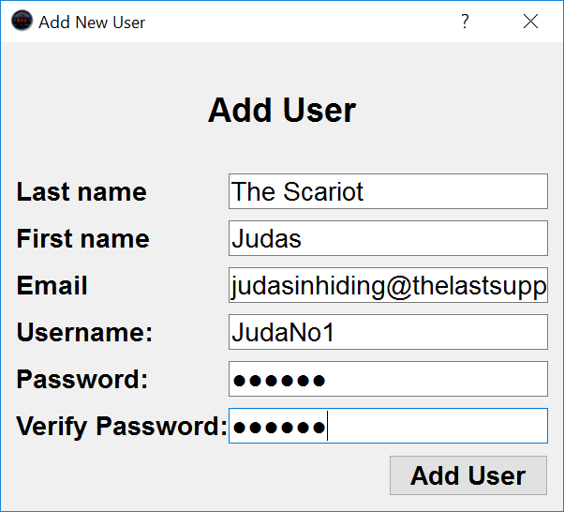

Figure 10 Add User

This GUI allows the System Administrator to enter details about the new user. Once the user has been created, it can be used immediately.

# Generate Report

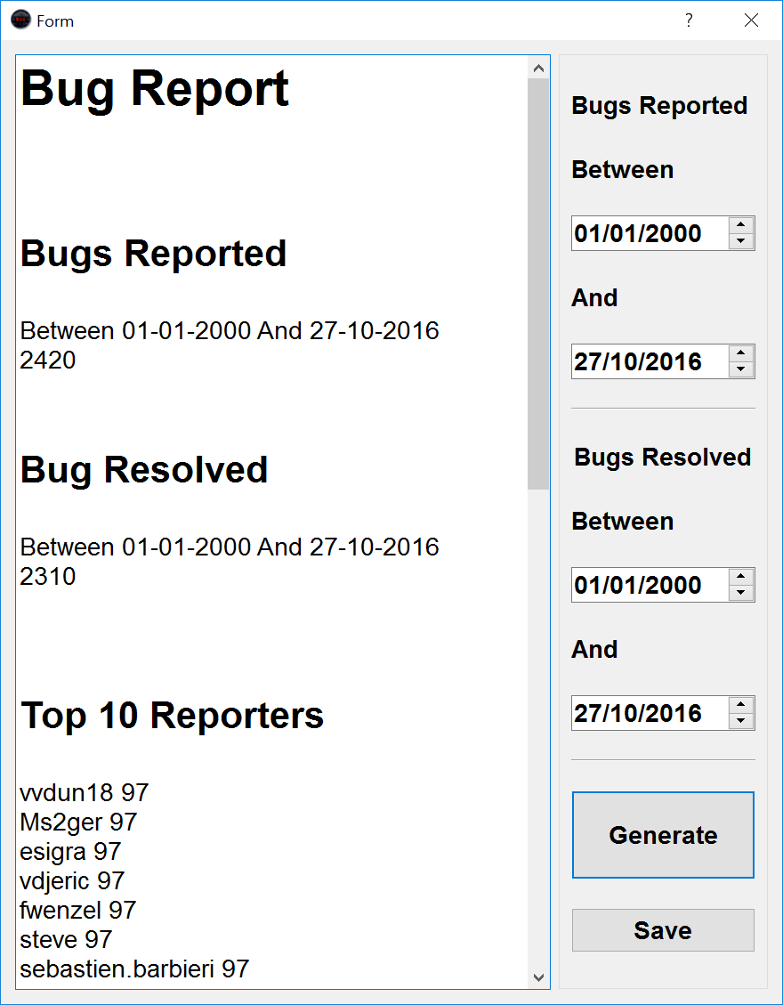This GUI is used to generate statistical analysis within the system.  
  
It can generate the following:

Figure 11 Generate Report

* Number of bugs reported within given dates.
* Number of bugs resolved within given dates
* Top 10 best reports
* Top 10 best Reviewers
* Top 10 best Developers